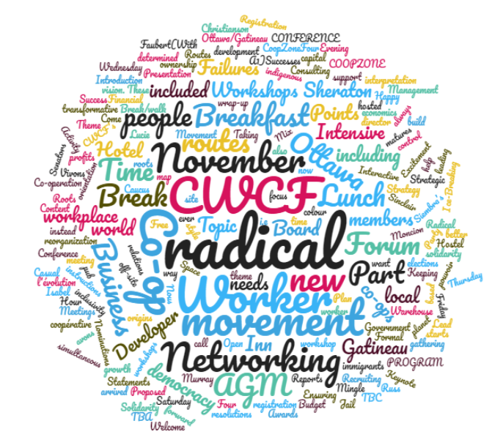

**2017 CONFERENCE PROGRAM**

**Canadian Worker Co-op Federation and CoopZone**

Ottawa/Gatineau

**Business Inn, Ottawa / Four Points Sheraton Hotel, Gatineau**

**Theme:**

**Radical Roots/ Radical Routes of Worker Co-operation**

**Nous avons le pouvoir. Vivons l'évolution coopérative!**

The movement for workplace democracy has always had a radical, transformative vision. These radical roots also call us to new radical *routes*, i.e., what is our way forward as a movement of solidarity economics based on ownership and control instead of capital?   The world needs workplace democracy now more than ever; it needs people and planet before profits.  Come to our Conference to help us map out these radical routes, to build this new and better world.

 In collaboration with:



|  |  |
| --- | --- |
| Time | Wednesday November 1 |
| 7:00 pm to 10:00 pm | Casual Evening gathering, at a local pub (TBA) |
|  |  |

|  |  |  |
| --- | --- | --- |
| Time | Thursday November 2 | |
| 8:00 am  8:15 am | Breakfast on your own  Registration starts at both hotels. | |
| 9:00 am to 4:00 pm  Lunch on your own | **Worker Co-op Management Intensive**  1) Financial Management of a worker co-operative.  2) Human Resources in a worker co-operative. Led by [Russ Christianson](http://www.ontario.coop/cms/documents/797/Russ_Christianson%2C_Rhyhtm_Communications_2013.pdf), and [Isabel Faubert Mailloux](http://www.reseau.coop/actualite/nomination-de-isabel-faubert-mailloux-a-la-direction-generale-du-reseau-de-la-cooperation-du-travail-du-quebec-reseau/), Executive Director of the Quebec Worker Co-op Réseau  Also with a presentation on Co-operators products available to worker co-ops.  (With simultaneous interpretation)  Business Inn, Ottawa | **Co-op Developer Intensive**  Includes a presentation about some dynamic new ways to develop co-ops, a workshop on important Québec models (CUMA and CUMO), a presentation of some new co-ops, and an item on the insurance specialized for co-operatives from The Co-operators. There will also be a presentation and discussion of the new CoopZone Strategic Plan which seeks to take the CoopZone Network to a new level, and other topics.  Four Points Sheraton Hotel, Gatineau |
| 6:00 to 8:00 | Solidarity Happy Hour (location TBC) | |

|  | Friday November 3 | | |
| --- | --- | --- | --- |
| 8:00am  8:15 am | Breakfast on your own  Registration starts | | |
| 9:00 to 10:10am | Welcome  Introduction to the Theme and Ice-Breaking Activity | | |
| 10:10 to 10: 30am | Networking Break | | |
| 10:30 to 11:40am | Keynote: Senators [Lucie Moncion](https://sencanada.ca/en/senators/moncion-lucie/) and [Murray Sinclair](https://sencanada.ca/en/senators/sinclair-murray/) - with focus on the theme. | | |
| 11:40 to 12:10 | CWCF AGM Part 1: Reports | | |
| 12:10 to 12:55pm | Lunch (included in registration) | | |
| 12:55 to 1:30pm | Movement Break/walk | | |
| 1:30 to 3:00pm | Forum Topic #1: Radical Roots to Radical Routes: a visionary approach to take the worker co-op movement where we want to go, to have a real impact on the economy. Ensuring radical inclusivity at the same time – e.g. of, immigrant and Indigenous people, people of colour, young people, and anyone who is marginalized. Presenters: Mo Manklang, Communications Director, [USFWC](https://usworker.coop/home/) and Omar Yaqub, a worker owner with [Alif Partners](http://alifpartners.com/) Worker Co-op. | | |
| 3:00 to 3:20pm | Networking Break | | |
| 3:20 to 4:30pm | Workshops: | | |
|  | A1) Learning from Co-op Failures to Lead to Success (with simultaneous interpretation) | A2) Government Relations Workshop facilitated by Alain Roy, CWCF Government Affairs Advisor, with Hazel Corcoran, CWCF (in English/ bilingual) | A3) Business Strategy, Interactive Style led by Christine Joly (Réseau) and Jessica Provencher (La Barberie Worker Co-op).  Bilingual |
| 4:35 to 5:35 | Caucus Meetings | | |
| 6:15-8:15pm | Mix and Mingle Networking Party with Awards Presentation, hosted by local co-ops including Brierwood and CDR Outaouais-Laurentides at La Siembra’s Warehouse, 250 City Centre, Ottawa.  Awards:   1. Mark Goldblatt Merit Award: presented to Alain Bridault, Coop Orion 2. Worker Co-op Best Practices Award: presented to La Siembra Co-op | | |
|  |  | | |

|  |  |  |  |
| --- | --- | --- | --- |
|  | Saturday November 4 | | |
| 8:00am  8:15 am | Breakfast on your own  Registration starts | | |
| 9:00 to 10:15am | Forum Topic #2: CWCF’s Proposed new Strategic Plan:  what do our members want CWCF to do, to support the growth and development of worker co-ops and the movement?    Led by CWCF's Strategic Planning Committee, Reba Plummer, Lee Fuge, Hazel Corcoran, & Kaye Grant | | |
| 10:15 to 10: 45 | CWCF AGM Part 2: Financial Statements and Budget | | |
| 10:45 to 11: 05 | Networking Break | | |
| 11:05 to 11:50 | CWCF AGM Part 3: Nominations, director elections and resolutions | | |
| 11:50 to 12:15 | Formal wrap-up and instructions for off-site workshops | | |
| 12:15 to 1:00 | Lunch – (included) | | |
| 12:15 to 1:00 | Board reorganization meeting | | |
| 1:00 to 4:00pm | Workshops: (off site – hosted by local co-op organizations) | | |
|  | B1) Keeping the Excitement as your Worker Co-op Matures  (In English)  Hosted by [La Siembra Co-op](https://camino.ca/) | B2) Recruiting and Orientation for New Members  (With simultaneous interpretation)  Led by [Isabel Faubert Mailloux](http://www.reseau.coop/actualite/nomination-de-isabel-faubert-mailloux-a-la-direction-generale-du-reseau-de-la-cooperation-du-travail-du-quebec-reseau/) and Mathieu Dionne (both of the Réseau)  Hosted by [Coopérative de développement régional-Outaouais](http://www.cdrol.coop/) | B3) Open Forum Space Organized by Eric Tusz-King and Jessica Provencher including Free Consulting Time by a Developer  (In English)  Hosted by [Brierwood Co-operative](http://www.brierwood.coop) |