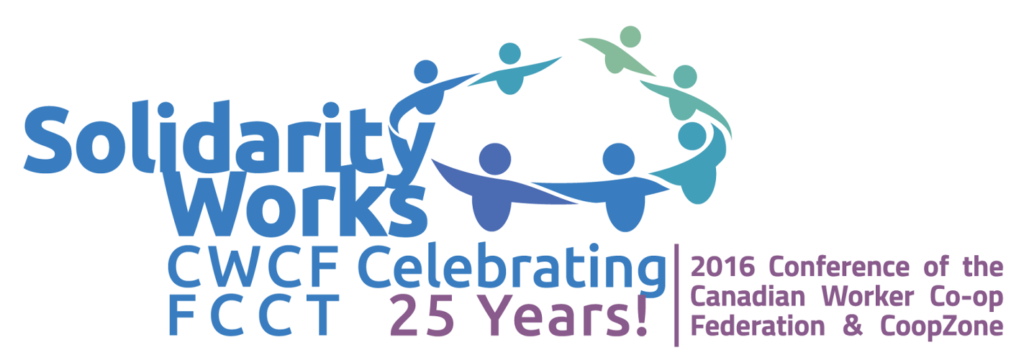

Worker Co-op Stories - Co-op Ignite style
CWCF-CoopZone Conference 2016

A “Co-op Ignite” presentation is one in which worker co-operators, and some other participants, will each briefly tell their story based on the Ignite approach- as adapted by CWCF. Each participant presents 20 slides, which auto-advance at 21 seconds each, for a total of 7 minutes. A great way to learn a lot in a short time.

Thursday, November 3, 2015 (11:15 am to 12noon)

 | Joy Emmanuel, Turning Times | What is a Worker Co-op
 | Rob Baxter | Vancouver Renewable Energy Co-op
 | Ray Morgan | Left Hand Media Co-op
 | Chris Nichols | Woodshop Workers’ Co-op
 | Peter Driftmier | The Grain Exchange
 | Mike Smith-Cairns | HASTe Worker’s Co-op

